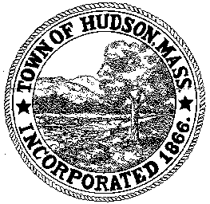

CONSERVATION COMMISSION
78 Main Street, Hudson, MA 01749
(978) 568-2020

Paul Byrne, Chairman W. Minot Wood, Vice Chairman David Esteves, Member

Terrence Joyce, Member Leif Longtine, Member Joseph Rodrigues, Member Al Tashian, Member

Agenda
October 1, 2009 7:00 P.M.

- Preliminaries
  - Open Meeting
  - Roll Call
1.3 Additions or Deletions to the agenda

2.0 Hearings and Appointments
2.1 RDA 387 continued
Applicant: Carol Morrell
Location: 69 Priest Street
Project Description: The installation of a 24’ round above ground pool

2.2 RDA 353 continued
Bob Crouse
Location: 91 Hunter Avenue
Project Description: removal of stairs

2.3 Enforcement Order 1 Zina Road - continued
Rick Colacchio

3.0 General Business
3.1 Sign Certificate of Compliance DEP 190-457

4.0 Adjournment

Next Meeting October 15, 2009

